**Role Profiles**

|  |  |
| --- | --- |
| **Role** | **Description** |
| System Administrator | System Administrator will manage AWS services, start/stop services, reboot the system and initialize the Client(s) |
| Client Account Administrator | Client Account Administrator will register IoT devices, create content, approve submitted content, publish content, and add section administrators & other Client Account Administrators |
| Client Account Owner | A client account administrator who is the root “owner” of the Client Account; the first use for that account. There is only one. Can be transferred. |
| Section Administrator | Section Administrator manages a subset of devices in a section within a Client, but does not have access to other sections in that Client |
| End User | End User will be able to view content and request content to be published |

System Administrator - 1.x

Client Account Administrator - 2.x

Client Account Administrator or Section Administrator - 3.x

End User - 4.x

## System Administrator - 1.x

As a System Administrator, I would like to log in to the Info Kiosk Web Application

|  |  |  |  |
| --- | --- | --- | --- |
| **Use Case ID:** | 1.01 | | |
| **Use Case Name:** | Log into system admin page | | |
| **Satisfies Reqs:** | 1a.1.1 | | |
| **Created By:** | Philip Bedward | **Last Updated By:** | Matthew Dunn |
| **Date Created:** | November 10, 2018 | **Date Last Updated:** | January 22, 2019 |

|  |  |
| --- | --- |
| **Actors:** | System Administrator |
| **Description:** | The actor can log into the web app to visit the admin landing page |
| **Trigger:** | A system admin needs to perform some admin-only action(s) |
| **Preconditions:** | The actor’s account already exists, created by a system administrator |
| **Post conditions:** | The system administrator is viewing the System Administrator dashboard |
| **Normal Flow:** | 1. Log in to the interactive kiosk website using an admin user and password    1. Taken to the admin view of the interactive kiosk website, a list of Clients 2. Can view all actions that administrators are permitted to perform |
| **Alternative and Exception Flows:** | Email invalid:  Follow step 1   1. Submission fails due to an invalid email 2. Follow step 1 again |

Sequence Diagram

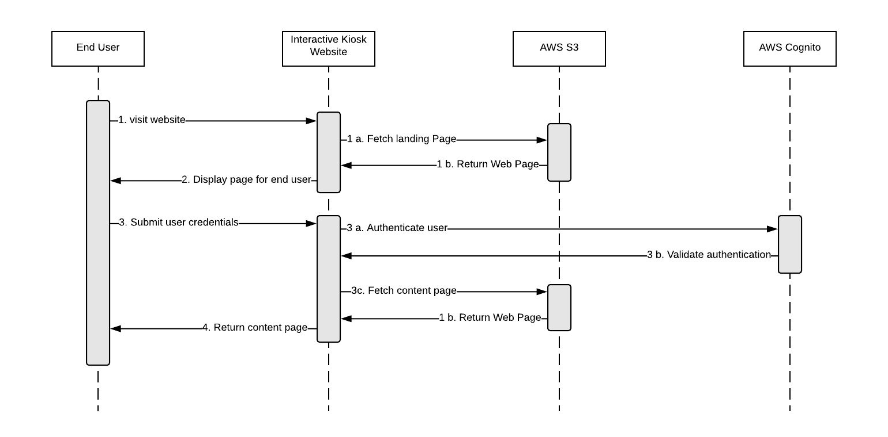

As a System Administrator I want to add a Client Account so that new institutions can manage their content on their smart TV devices.

|  |  |  |  |
| --- | --- | --- | --- |
| **Use Case ID:** | 1.02 | | |
| **Use Case Name:** | Add A Client Account | | |
| **Satisfies Reqs:** | 1a.1.2 | | |
| **Created By:** | Matthew Dunn | **Last Updated By:** | Matthew Dunn |
| **Date Created:** | September 11, 2018 | **Date Last Updated:** | January 22, 2019 |

|  |  |
| --- | --- |
| **Actors:** | System Administrator |
| **Description:** | System Administrator can add new Clients Accounts for new institutions |
| **Trigger:** | New Client Account Owner requests an account from a System Administrator |
| **Preconditions:** | New Client Account Owner specified what Client name and email to use  System Administrator is logged in to the Web App |
| **Post conditions:** | New Client Account is added to the system |
| **Normal Flow:** | 1. Select an “Add a Client” button 2. Client Settings entry appears    1. Enter Client Name    2. Enter Client Account Owner’s username/email 3. Submit 4. Redirected to list of client accounts |
| **Alternative and Exception Flows:** | N/A |

As a System Administrator, I would like to view all of my Client Accounts as well as details about them

|  |  |  |  |
| --- | --- | --- | --- |
| **Use Case ID:** | 1.03 | | |
| **Use Case Name:** | View All Client Accounts and their Details | | |
| **Satisfies Reqs:** | 1a.1.3 | | |
| **Created By:** | Matthew Dunn | **Last Updated By:** | Matthew Dunn |
| **Date Created:** | January 23, 2019 | **Date Last Updated:** | January 23, 2019 |

|  |  |
| --- | --- |
| **Actors:** | System Administrator |
| **Description:** | System Administrator wants to manage their Client Accounts |
| **Trigger:** | The actor would like to view information about a specific client |
| **Preconditions:** | There is at least one Client Account created  The actor is logged in to the system |
| **Post conditions:** | The system Administrator can view the Client Account’s information |
| **Normal Flow:** | 1. The actor selects a button to list all clients 2. A list of all client accounts appears 3. The actor selects the desired client account 4. A details page for the client account appears |
| **Alternative and Exception Flows:** | N/A |

As a System Administrator, I would like to view all existing devices (Registered to the Client Accounts and their respective Sections as well as unassigned)

|  |  |  |  |
| --- | --- | --- | --- |
| **Use Case ID:** | 1.04 | | |
| **Use Case Name:** | View All Devices Within All of My Client Accounts | | |
| **Satisfies Reqs:** | 1a.1.4 | | |
| **Created By:** | Matthew Dunn | **Last Updated By:** | Matthew Dunn |
| **Date Created:** | January 23, 2019 | **Date Last Updated:** | January 23, 2019 |

|  |  |
| --- | --- |
| **Actors:** | System Administrator |
| **Description:** | System Administrator wants to view all devices |
| **Trigger:** | The actor would like to view information about a specific device |
| **Preconditions:** | There is at least one Client Account created  The actor is logged in to the system  There is at least one Device registered to said Client Account |
| **Post conditions:** | The system Administrator can view the device’s information |
| **Normal Flow:** | 1. The actor selects a button to list all devices 2. A list of all devices with details about it populated in the columns |
| **Alternative and Exception Flows:** | N/A |

## Client Account Administrator - 2.x

As a Client Account Administrator I want to access the settings so that I can change my client account information/functionality

|  |  |  |  |
| --- | --- | --- | --- |
| **Use Case ID:** | 2.01 | | |
| **Use Case Name:** | Access Interactive Kiosk Client Account Owner Settings Page | | |
| **Satisfies Reqs:** | 1a.2.6 | | |
| **Created By:** | Matthew Dunn | **Last Updated By:** | Matthew Dunn |
| **Date Created:** | September 11, 2018 | **Date Last Updated:** | January 23, 2019 |

|  |  |
| --- | --- |
| **Actors:** | Client Account Administrator |
| **Description:** | Actor has the ability to select the settings page for that client account |
| **Trigger:** | Make changes to client account settings |
| **Preconditions:** | Client Account Administrator has been set up by the System Administrator  Actor is logged in to the interactive kiosk website |
| **Post conditions:** | Directed to settings page |
| **Normal Flow:** | 1. Select the settings button 2. Directed to the settings page |
| **Alternative and Exception Flows:** | N/A |

## 

As a Client Account Administrator I want to add a new section so that I can more finely manage where content will be displayed within their institutions.

|  |  |  |  |
| --- | --- | --- | --- |
| **Use Case ID:** | 2.02 | | |
| **Use Case Name:** | Add a new section to an active Client Account | | |
| **Satisfies Reqs:** | 1a.2.2 | | |
| **Created By:** | Philip Bedward | **Last Updated By:** | Matthew Dunn |
| **Date Created:** | November 12, 2018 | **Date Last Updated:** | January 22, 2019 |

|  |  |
| --- | --- |
| **Actors:** | Client Account Administrator |
| **Description:** | Client Account Administrator should be able to create a division within their client account to add Smart TVs to with it’s own administrator/s |
| **Trigger:** | Actor would like to divide their Smart TVs in to more easily managed sections |
| **Preconditions:** | Client account has been set up by the System Administrator  Actor is logged in to the interactive kiosk website |
| **Post conditions:** | New section is created under the Client Account |
| **Normal Flow:** | 1. Select the Client Account settings 2. Navigate to Sections list 3. Select “Add New Section”    1. An input field is displayed for the section name 4. Enter a name for the new section 5. The actor selects the submit button 6. The new section is added to the list of sections |
| **Alternative and Exception Flows:** | N/A |

As a Client Account Administrator, I would like to delegate work to other employees without giving them access to the entire system.

|  |  |  |  |
| --- | --- | --- | --- |
| **Use Case ID:** | 2.03 | | |
| **Use Case Name:** | Add a Section Administrator to an Active Section | | |
| **Satisfies Reqs:** | 1a.2.3 | | |
| **Created By:** | Philip Bedward | **Last Updated By:** | Matthew Dunn |
| **Date Created:** | November 12, 2018 | **Date Last Updated:** | January 22, 2019 |

|  |  |
| --- | --- |
| **Actors:** | Client Account Administrator |
| **Description:** | Client Account Administrator should be able to give permissions to a new section administrator in their active Client |
| **Trigger:** | A client account administrator would like to share only some responsibilities and permissions with another user, especially for a particular set of Smart TVs |
| **Preconditions:** | Client account has been set up by the System Administrator  Actor logged in to the interactive kiosk website |
| **Post conditions:** | New Section Administrator is given permissions over the selected Section |
| **Normal Flow:** | 1. Select the Client Account settings |
| **Alternative and Exception Flows:** | VIA Section   1. Navigate to Sections list 2. Select desired Section 3. Section details page is displayed 4. Select “Manage Section Administrators” 5. Select Add Section Administrator button 6. A selection pops up for Existing or New user   Existing User   1. Select the user from a drop-down   New User   1. An input field appears to add their username/email 2. Select “Send”    1. A link is sent to the new account owner to register their email with a password on the site   VIA Manage Users, assuming the user already exists   1. Navigate to Manage Users    1. A list of all users within the client account and their roles is displayed 2. Select the desired users 3. Change their account role to Section Administrator 4. Select the section from the drop-down |

## 

As a Client Account Administrator I want to add a Client Account Administrator to an active Client so that the workload can be shared across multiple employees.

|  |  |  |  |
| --- | --- | --- | --- |
| **Use Case ID:** | 2.04 | | |
| **Use Case Name:** | Add a Client Account Administrator to an Active Client | | |
| **Satisfies Reqs:** | 1a.2.1 | | |
| **Created By:** | Matthew Dunn | **Last Updated By:** | Matthew Dunn |
| **Date Created:** | September 11, 2018 | **Date Last Updated:** | January 22, 2019 |

|  |  |
| --- | --- |
| **Actors:** | Client Account Administrator |
| **Description:** | Client Account Administrator should be able to give permissions to their Client Account to a new Client Account Administrator |
| **Trigger:** | A client account administrator would like to share their full responsibilities and permissions with another user |
| **Preconditions:** | Client account has been set up by the System Administrator  Actor is logged in to the interactive kiosk website |
| **Post conditions:** | New Owner is given permissions over the selected Client |
| **Normal Flow:** | 1. Select the Client Account settings 2. Navigate to Manage Users    1. A list of all users within the client account and their roles is displayed |
| **Alternative and Exception Flows:** | User exists already:  Follow steps 1-2a   1. Select the desired user 2. Change their account role to Account Administrator   User account does not exist:  Follow steps 1-2a   1. Select an “Add user” button 2. Add their username/email 3. Select the “Account Administrator” Role 4. Select “Send” |

## 

As a Client Administrator, I would like to assign a registered device to a section

|  |  |  |  |
| --- | --- | --- | --- |
| **Use Case ID:** | 2.05 | | |
| **Use Case Name:** | Assign a device to a Section in my Client Account | | |
| **Satisfies Reqs:** | 1a.2.4 | | |
| **Created By:** | Matthew Dunn | **Last Updated By:** | Matthew Dunn |
| **Date Created:** | January 23, 2019 | **Date Last Updated:** | January 23, 2019 |

|  |  |
| --- | --- |
| **Actors:** | Client Account Administrator |
| **Description:** | The actor would like to assign a device that has been registered to a section within their Client Account |
| **Trigger:** | A Section Administrator or Client Account Owner has had a registration request accepted and would like it assigned to a Section to group it with other similar Smart TVs and make it easier to locate |
| **Preconditions:** | Client Account exists  Smart TV registration request has been accepted |
| **Post conditions:** | Smart TV has been added to a Section within the Client Account |
| **Normal Flow:** | 1. Actor navigates to a list of devices 2. Actor is able to identify which devices are not assigned to a Section 3. Actor selects device they would like to assign to a section 4. A drop-down is displayed with a list of Sections within the Client Account 5. The actor selects their desired Section 6. The actor commits the change |
| **Alternative and Exception Flows:** | N/A |

## Client Account Administrator or Section Administrator - 3.x

As a Client Account Administrator or Section Administrator, I would like to log in to my account

|  |  |  |  |
| --- | --- | --- | --- |
| **Use Case ID:** | 3.01 | | |
| **Use Case Name:** | Section Administrator or Client Account Administrator Log-In | | |
| **Satisfies Reqs:** | 1a.3.1 | | |
| **Created By:** | Matthew Dunn | **Last Updated By:** | Matthew Dunn |
| **Date Created:** | January 23, 2019 | **Date Last Updated:** | January 23, 2019 |

|  |  |
| --- | --- |
| **Actors:** | Client Account Administrator or Section Administrator |
| **Description:** | The actor can log into the web app to visit the Client Account Administrator or Section Administrator landing page |
| **Trigger:** | A client account admin or section admin needs to perform some admin-only action(s) |
| **Preconditions:** | The actor’s account already exists |
| **Post conditions:** | The client account administrator or section administrator is viewing their dashboard |
| **Normal Flow:** | 1. Log in to the interactive kiosk website using an admin user and password    1. Taken to the admin view of the interactive kiosk website, a list of Clients 2. Can view all actions that administrators are permitted to perform |
| **Alternative and Exception Flows:** | Email invalid:  Follow step 1   1. Submission fails due to an invalid email 2. Follow step 1 again |

Sequence Diagram



As a Client Account Administrator or Section Administrator, I want to register a smart TV device so that it can be used to display content

|  |  |  |  |
| --- | --- | --- | --- |
| **Use Case ID:** | 3.02 | | |
| **Use Case Name:** | Register Smart TV | | |
| **Satisfies Reqs:** | 1a.2.5, 1a.3.10 | | |
| **Created By:** | Aaron Liu | **Last Updated By:** | Matthew Dunn |
| **Date Created:** | September 11, 2018 | **Date Last Updated:** | January 22, 2018 |

|  |  |
| --- | --- |
| **Actors:** | Client Account Administrator, Section Administrator |
| **Description:** | Client Account Administrator or Section Administrator needs to register a new smart TV before pushing content to it |
| **Trigger:** | Someone within the Client Account wants to Register a new smart TV to the account |
| **Preconditions:** | Client Account Administrator and/or Section Administrator account has been set up  Smart TV App is downloaded on to the Smart TV |
| **Post conditions:** | Smart TV is registered and shown in the list of IoT devices for that section |
| **Normal Flow:** | 1. Actor walks up to the Smart TV 2. Actor selects the Info Kiosk Smart TV App on the Smart TV 3. Smart TV App opens 4. Actor selects a button to register Smart TV 5. Screen is displayed showing mac address information, an input field for Client Account and a registration request button 6. Actor enter in the client ID into the input field 7. Actor selects registration request button 8. Client Account Administrator opens the interactive kiosk web application on a mobile or desktop device 9. Client Account Administrator navigates to a list of registration requests 10. Client Account Administrator selects the registration request 11. A page displays the mac address and a drop down field populated with sections that have been entered for a specific domain as well as an approve button and a deny button |
| **Alternative and Exception Flows:** | Approve a Registration Request:  Perform steps 1-11   1. Selects the section they want the smart tv in 2. Select approve registration button 3. On the Smart TV, the Client Account Administrator or Section Administrator confirms the registration through a success message displayed. 4. Smart TV is Registered   Deny a Registration Request:  Perform steps 1-11   1. Client Account Administrator selects “Deny Request” 2. On the Smart TV, a denied registration message is displayed |

As a Client Account Administrator or Section Administrator, I want to view all open content requests

|  |  |  |  |
| --- | --- | --- | --- |
| **Use Case ID:** | 3.03 | | |
| **Use Case Name:** | View All Open Content Requests | | |
| **Satisfies Reqs:** | 1a.3.2 | | |
| **Created By:** | Matthew Dunn | **Last Updated By:** | Matthew Dunn |
| **Date Created:** | September 11, 2018 | **Date Last Updated:** | January 22, 2019 |

|  |  |
| --- | --- |
| **Actors:** | Client Account Administrator, Section Administrator |
| **Description:** | A Client Account Administrator has the ability to view all end-user submitted content requests for the Client Account and a Section Administrator has the ability to view all end-user submitted content requests for their section |
| **Trigger:** | Actor would like to see what open requests there are |
| **Preconditions:** | Actor has been set up by the System Administrator  Actor is logged in to the interactive kiosk website |
| **Post conditions:** | Actor is viewing list of content requests |
| **Normal Flow:** | 1. Select option to view open content requests    1. Taken to a list of content requests with the content and the user requesting |
| **Alternative and Exception Flows:** | N/A |

As a Client Account Administrator or Section Administrator I want to approve or deny a content request so that the content in my client account can be properly managed

|  |  |  |  |
| --- | --- | --- | --- |
| **Use Case ID:** | 3.04 | | |
| **Use Case Name:** | Approve or Deny a Content Request | | |
| **Satisfies Reqs:** | 1a.3.3 | | |
| **Created By:** | Matthew Dunn | **Last Updated By:** | Matthew Dunn |
| **Date Created:** | September 11, 2018 | **Date Last Updated:** | January 22, 2019 |

|  |  |
| --- | --- |
| **Actors:** | Client Account Administrator, Section Administrator |
| **Description:** | Actor should be able approve or deny a content request sent to them |
| **Trigger:** | Content request to be published is present in the system |
| **Preconditions:** | Actor has been set up by the System Administrator  Logged in to the interactive kiosk website |
| **Post conditions:** | Content approved and published or denied and not published |
| **Normal Flow:** | 1. Select view content requests    1. Taken to a list of content requests with the content and the user requesting 2. Select on a single content request    1. More information about the content request is displayed    2. An approve button and a deny button appear |
| **Alternative and Exception Flows:** | Select approve:   1. A window asking which tv to push content to appears    1. Select the Smart TV/s to push to       1. The number of items available to be able to push is displayed       2. Confirm they want to push the tile    2. The tile is sent to the tv and is displayed   Select deny:   1. Taken back to the view content requests page |

As a Client Account Administrator or Section Administrator I want to create my own content so that I can push information to a Smart TV

|  |  |  |  |
| --- | --- | --- | --- |
| **Use Case ID:** | 3.05 | | |
| **Use Case Name:** | Create Content | | |
| **Satisfies Reqs:** | 1a.3.4 | | |
| **Created By:** | Matthew Dunn | **Last Updated By:** | Matthew Dunn |
| **Date Created:** | September 11, 2018 | **Date Last Updated:** | January 22, 2019 |

|  |  |
| --- | --- |
| **Actors:** | Client Account Administrator, Section Administrator |
| **Description:** | Actor should have ability to create their own content |
| **Trigger:** | The actor would like to create new content |
| **Preconditions:** | Actor’s account has been set up in the system  Actor is logged in to the interactive kiosk website |
| **Post conditions:** | Content shown in the list of unpublished content |
| **Normal Flow:** | 1. Select a button to publish new content 2. Input information related to the content    1. Title    2. Description    3. Content to be contained in QR code 3. Submit input    1. New content shown on unpublished list |
| **Alternative and Exception Flows:** | Creating more content:  Follow steps 1-3a   1. A prompt opens asking to submit more content    1. If the user selects yes, the input information window is refreshed    2. If the user selects no, the display switches back to the list of unpublished content |

Sequence Diagram

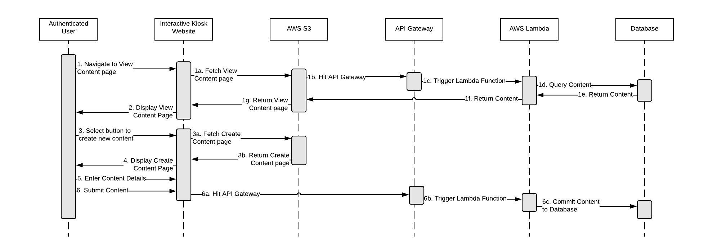

As a Client Account Administrator or Section Administrator I want to view all available content, submitted by both end users and administrators, so that I can know what content is available to be displayed on a smart TV.

|  |  |  |  |
| --- | --- | --- | --- |
| **Use Case ID:** | 3.06 | | |
| **Use Case Name:** | View Available Content | | |
| **Satisfies Reqs:** | 1a.3.5 | | |
| **Created By:** | Matthew Dunn | **Last Updated By:** | Matthew Dunn |
| **Date Created:** | September 11, 2018 | **Date Last Updated:** | January 22, 2019 |

|  |  |
| --- | --- |
| **Actors:** | Client Account Administrator, Section Administrator |
| **Description:** | Actor has access to view the content being published |
| **Trigger:** | The actor would like to publish content |
| **Preconditions:** | Client Account Administrator has been set up by the System Administrator  Content has been created  Actor is logged in to the system |
| **Post conditions:** | A list of content is displayed to the Client Administrator |
| **Normal Flow:** | 1. The actor selects a button to view a list of all unpublished content 2. A page loads containing a pinterest-style view of the content available to be published |
| **Alternative and Exception Flows:** | N/A |

Sequence Diagram

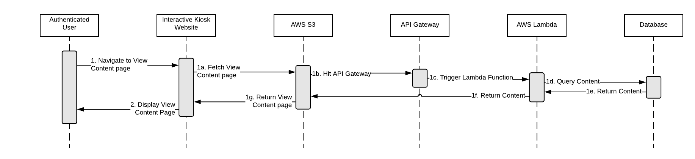

As a Client Account Administrator or Section Administrator I want to push content to a smart TV so that I can update/manage what content is being displayed on a specific TV

|  |  |  |  |
| --- | --- | --- | --- |
| **Use Case ID:** | 3.07 | | |
| **Use Case Name:** | Push Content to a Smart TV | | |
| **Satisfies Reqs:** | 1a.3.5, 1a.3.6 | | |
| **Created By:** | Matthew Dunn | **Last Updated By:** | Matthew Dunn |
| **Date Created:** | September 11, 2018 | **Date Last Updated:** | January 22, 2019 |

|  |  |
| --- | --- |
| **Actors:** | Client Account Administrator or Section Administrator |
| **Description:** | Actor should have access to push content to a smart tv |
| **Trigger:** | Manage content on smart TV |
| **Preconditions:** | Client account has been set up by the System Administrator  Actor is Logged in to the interactive kiosk website |
| **Post conditions:** | Content is pushed to the smart TV |
| **Normal Flow:** | 1. The actor selects a button to view a list of all unpublished content 2. A page loads containing a pinterest-style view of the content available to be published 3. The actor selects a specific content item to be pushed to Smart TV/s 4. Prompted with a window asking which TV/s to push content to 5. The actor selects the TV/s    1. Shown how many items may currently be pushed to the Smart TV/s    2. Confirm/deny they want to push the tile 6. The content tile is sent to the Smart TV/s and is displayed on the Smart TV/s |
| **Alternative and Exception Flows:** | N/A |

Sequence Diagram

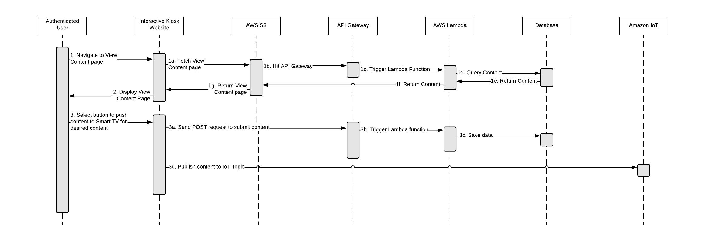

As a new Client Account Administrator or Section Administrator, I would like to be able to access my new account to use the Information Kiosk Web App

|  |  |  |  |
| --- | --- | --- | --- |
| **Use Case ID:** | 3.08 | | |
| **Use Case Name:** | Log in to new Client Account Administrator account or Section Administrator Account on the Information Kiosk Web app | | |
| **Satisfies Reqs:** | 1a.2.1.1, 1a.2.3.1, 1a.3.11 | | |
| **Created By:** | Matthew Dunn | **Last Updated By:** | Matthew Dunn |
| **Date Created:** | November 24, 2018 | **Date Last Updated:** | January 22, 2019 |

|  |  |
| --- | --- |
| **Actors:** | New Client Account Administrator or Section Administrator |
| **Description:** | The actors should be able to login and register their new accounts on the infokiosk webapp with a password of their choosing |
| **Trigger:** | Client Account Administrator sends email to new user to register their new account |
| **Preconditions:** | Client Account Administrator sends email to new user  Client Account exists |
| **Post conditions:** | New Owner is given permissions over the selected Client or Section |
| **Normal Flow:** | 1. Select link to web app within an email    1. Redirected to infokiosk web app 2. Enter password for new account    1. Redirected to login page 3. Use new credentials to log in |
| **Alternative and Exception Flows:** | N/A |

As a Client Account Administrator or Section Administrator, I would like to view all the TVs within my scope

|  |  |  |  |
| --- | --- | --- | --- |
| **Use Case ID:** | 3.09 | | |
| **Use Case Name:** | View all TVs registered to my Section or Client Account | | |
| **Satisfies Reqs:** | 1a.3.8 | | |
| **Created By:** | Matthew Dunn | **Last Updated By:** | Matthew Dunn |
| **Date Created:** | January 23, 2019 | **Date Last Updated:** | January 23, 2019 |

|  |  |
| --- | --- |
| **Actors:** | Client Account Administrator or Section Administrator |
| **Description:** | Ability to view all smart TVs the actor is authorized to view |
| **Trigger:** | The actor would like to take account of and manage their devices |
| **Preconditions:** | Client Account Administrator or Section Administrator has an account  Devices exist within the Client Account or Section  The actor is logged in to the system |
| **Post conditions:** | The actor is viewing a list of all TVs they are authorized to view |
| **Normal Flow:** | 1. The user selects an option to view all TVs 2. A list of all TVs they are authorized to view appears |
| **Alternative and Exception Flows:** | N/A |

As a Client Administrator or Section Administrator, I would like to view all content currently deployed to a specific Smart TV

|  |  |  |  |
| --- | --- | --- | --- |
| **Use Case ID:** | 3.10 | | |
| **Use Case Name:** | View all content Deployed on a specific Smart TV | | |
| **Satisfies Reqs:** | 1a.3.7 | | |
| **Created By:** | Matthew Dunn | **Last Updated By:** | Matthew Dunn |
| **Date Created:** | January 23, 2019 | **Date Last Updated:** | January 23, 2019 |

|  |  |
| --- | --- |
| **Actors:** | Client Account Administrator or Section Administrator |
| **Description:** | View all content deployed to a Smart TV |
| **Trigger:** | The actor would like to see what content is being displayed on a certain Smart TV |
| **Preconditions:** | The actor is logged in to the system  A device exists within the client account  Content is pushed to a device |
| **Post conditions:** | The user is able to view the content displayed on a specific smart tv |
| **Normal Flow:** | 1. The user selects an option to view all TVs 2. A list of all TVs they are authorized to view appears 3. The user selects the desired Smart TV 4. The user selects an option to view all deployed content 5. A screen appears showing all of the content present on that TV |
| **Alternative and Exception Flows:** | N/A |

As a Client Account Administrator or Section Administrator, I would like to access settings for my own user account to I can update my account settings

|  |  |  |  |
| --- | --- | --- | --- |
| **Use Case ID:** | 3.11 | | |
| **Use Case Name:** | View account settings | | |
| **Satisfies Reqs:** | 1a.3.9 | | |
| **Created By:** | Matthew Dunn | **Last Updated By:** | Matthew Dunn |
| **Date Created:** | January 23, 2019 | **Date Last Updated:** | January 23, 2019 |

|  |  |
| --- | --- |
| **Actors:** | Client Account Administrator or Section Administrator |
| **Description:** | Access User Account Settings |
| **Trigger:** | The actor would like to review their personal account settings and update them if necessary |
| **Preconditions:** | The actor has an account in the Client Account  The actor is logged in |
| **Post conditions:** | The actor can view their settings |
| **Normal Flow:** | 1. Select a Menu button 2. Select Account Settings |
| **Alternative and Exception Flows:** |  |

## End User - 4.x

As an end user I want to be able to view and visit a URL so I can interact with the content that is referenced on the Smart TV tile

|  |  |  |  |
| --- | --- | --- | --- |
| **Use Case ID:** | 4.01 | | |
| **Use Case Name:** | Visit URL via QR code | | |
| **Satisfies Reqs:** | 2a.6 | | |
| **Created By:** | Philip Bedward | **Last Updated By:** | Matthew Dunn |
| **Date Created:** | November 11, 2018 | **Date Last Updated:** | January 22, 2019 |

|  |  |
| --- | --- |
| **Actors:** | End User |
| **Description:** | End User should be able to open their camera or QR code-reading app and use the QR code on-screen to navigate to the intended link |
| **Trigger:** | QR code is displayed |
| **Preconditions:** | End User has a device with a browser application, camera and QR code reading app |
| **Post conditions:** | Redirected to where the URL takes them |
| **Normal Flow:** | 1. Actor walks up to a smart TV display 2. Open a QR code reading app 3. Actor points camera to the QR code 4. The browser will send the user to the appropriate page 5. The App asynchronously logs the page while the user is redirected to the content |
| **Alternative and Exception Flows:** | N/A |

As an end user I want to submit request a content request, so that I can publish content on the smart TV that is important for me to share with others.

|  |  |  |  |
| --- | --- | --- | --- |
| **Use Case ID:** | 4.02 | | |
| **Use Case Name:** | Request to Publish Content | | |
| **Satisfies Reqs:** | 2a.11, 1a.4.1 | | |
| **Created By:** | Matthew Dunn | **Last Updated By:** | Matthew Dunn |
| **Date Created:** | September 11, 2018 | **Date Last Updated:** | January 22, 2019 |

|  |  |
| --- | --- |
| **Actors:** | End User |
| **Description:** | End User wants to publish content on the smart TV |
| **Trigger:** | QR code to publish to Smart TV is scanned by the actor |
| **Preconditions:** | End User has a phone and QR code scanner app on their phone |
| **Post conditions:** | Request to publish content is sent to the system for approval |
| **Normal Flow:** | 1. Scan web app QR code from Smart TV    1. User is taken to a content submittal form, displaying Device ID from uri endpoint 2. Input information related to the content    1. Title    2. Description    3. Content to be contained in QR code    4. Expiration date (default: 24hrs adjustable up to 7 days)    5. Email Address    6. Whether to push to Section or Singular Smart TV 3. Select the submit button    1. The request is sent to the Client Account Administrators for approval 4. A message is displayed to the user that the request was submitted and the page is refreshed, clearing fields |
| **Alternative and Exception Flows:** | N/A |